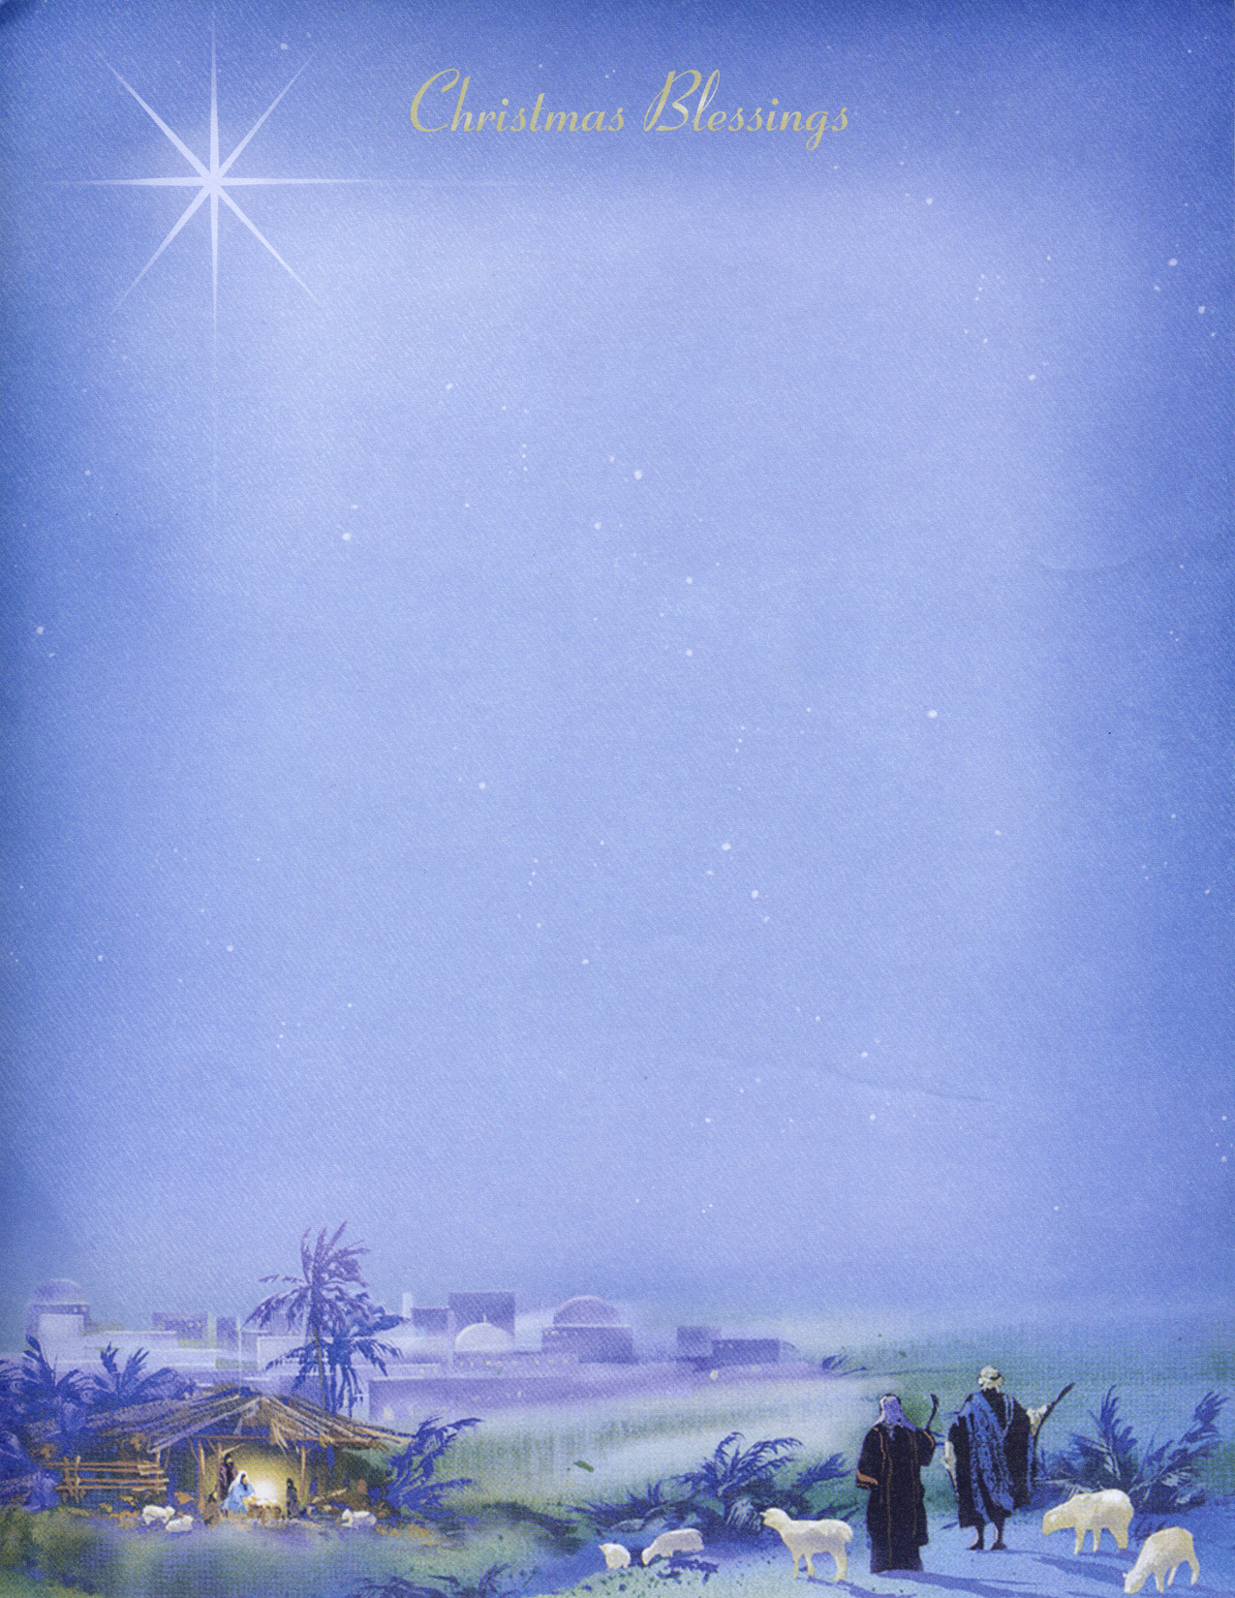
Christmas 2011

Dear Friends and Family,
Our thoughts and prayers are with you this joyous Christmas season.
What a blessing to be reminded once again during this special time of the year of God’s great gift of love, the Lord Jesus Christ, to sinful men, women, boys and girls. “Thanks be to God for His unspeakable gift” (2 Corinthians 9:15). A wonderful “Christmas Verse” is found in John 1:14, “And the Word was made flesh, and dwelt among us (and we beheld His glory, the glory as of the only begotten of the Father), full of grace and truth.”
Our hearts are grateful to the Lord that He has blessed with so many wonderful friends and family who have helped and encouraged us in our ministry with New Tribes Mission this past year. We have greatly appreciated your prayers, letters, and e-mails, as well as financial gifts of support. Thinking back over this past year, our hearts are filled with joy and thanksgiving. This coming January, Lord willing, we will have had the privilege of being involved in the ministry of reaching tribal people with the Gospel for 38 years! Looking back over the span of our ministry we can honestly say that “it will be worth it all.”
We are doing very well these days; our health has been good, for which we are very thankful. We continue to keep quite busy in our ministry the NTM Medical Plan office. At this time we are working on the completion of the 2012 Plan Policy.
In January 2011, Rory, our newest granddaughter was born to our son, Jeffrey, and his wife, Stefanie. It has been such a wonderful blessing having them living here in Sanford, Florida. We just found out that Jeffrey and Stefanie are expecting another baby in July 2012. We are very happy for them.
In March 2011, our daughter, Sarah, our son-in-law, David, and our two granddaughters, Kayla and Kennidy, moved from Texas to Dothan, Alabama. Already we have been able to see them several times for which we are very thankful. It is wonderful having them so much closer to us.
On April 26th, we, along with Tim, Jeffrey and family, and David helped to celebrate Mom and Dad Hansen’s 70th Wedding Anniversary. It was such a blessing to honor our dear parents and thank them for their consistent walk with the Lord and godly example to all of us. Mom and Dad are now living in an Assisted Living Facility in Birnamwood, Wisconsin since September.
Our oldest son, Tim, ran in the Virginia State senate race as the Republican candidate in November. Although he did not win the election, he did remarkably well and we are very proud of him. We are looking forward to seeing Tim when he comes home for Christmas!
Our youngest son, David, who is still living with us here at home, continues to do well as an IT (Information Technology) Specialist at K&K Electric, Inc. here in Sanford. This is the same company where Jeffrey works. The Lord has wonderfully given David a gift for working with computers and programs, which is also a blessing to us personally as he maintains our home computers. Lord willing our entire family will be home for Christmas.
In closing, we once again, thank you for your prayers and gifts to us. May every blessing be yours this joyous Christmas season.
All because of God’s great love,
John & Linda

John & Linda McGhee
New Tribes Mission • 1000 East First Street • Sanford, FL 32771-1487
www.GoYeMcGhee.com


